1. Open Jupyter Notebook (make sure packages install in you environment:

numpy

pygame

torch

matplotlib)

2. Change the directory for game tools

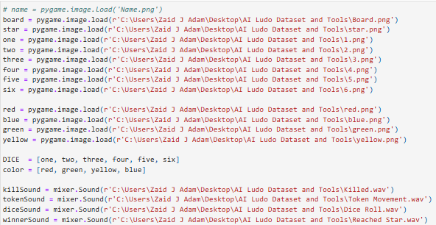

3. and change the directory of dataset



4. You can set game end. If you game Window end by 1st player done, then put 1. The game till first winner done and so on. I am not recommended to set to 4 players done…. It will take to long or one of will get stuck. Three is good to end and Window will closed.

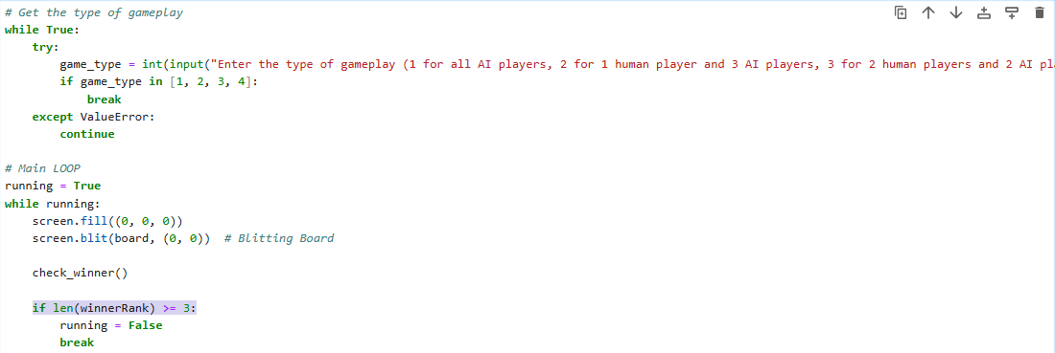

4. Run cells

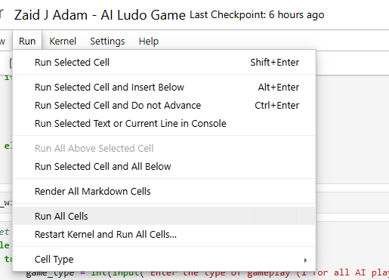

6. When run all. You will see



Pick 1 for AI x AI then hit enter



As you the game started

